Hibernate

Introduction to JPA:
- The Java Persistence API (JPA) is a specification that defines how to persist data in Java applications.
- Any storage system which stores the data permanently is called persistence store.
  - Ex: Files, Database’s etc .
  - Insert Update, delete, and select operations on the DB table are called persistence operations.
  - The logic used for this purpose is called persistence logic.
- Java Persistence API (JPA) is a Java specification used to store, retrieve, update, and delete data from a database using Java objects.
- The technologies which are used to develop persistence logic are called as persistence technologies. Ex: JDBC, Hibernate, JPA, IBATIS.
- JPA connects java and database automatically.

Database | Java
Table | Class
Row | Object
Column | Variable

Object-Relational Mapping (ORM)
- Object-Relational Mapping (ORM) is the process of converting Java objects to database tables.
- It is a technique that connects Java Objects with Database Tables. So you can work with Java classes, not SQL.
- Mapping Java Class with the Database table, member variables with the columns and making that java class objects representing rows of DB tables by having synchronization between them is called Object Relational Mapping (ORM).
- Synchronization between objects and rows of tables is nothing but, modifications done in java objects reflect in rows of tables and vice versa.
- All ORM technologies internally use JDBC code to perform persistence operations on DB table rows. Hence these ORM technologies are providing abstraction layer to programmers on JDBC. So ORM technologies are also called as framework technologies.

Relation between JPA and ORM
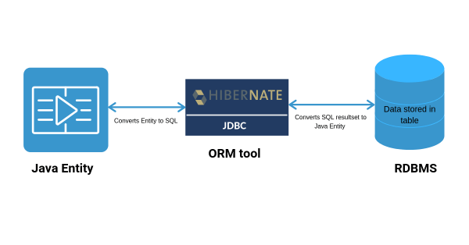

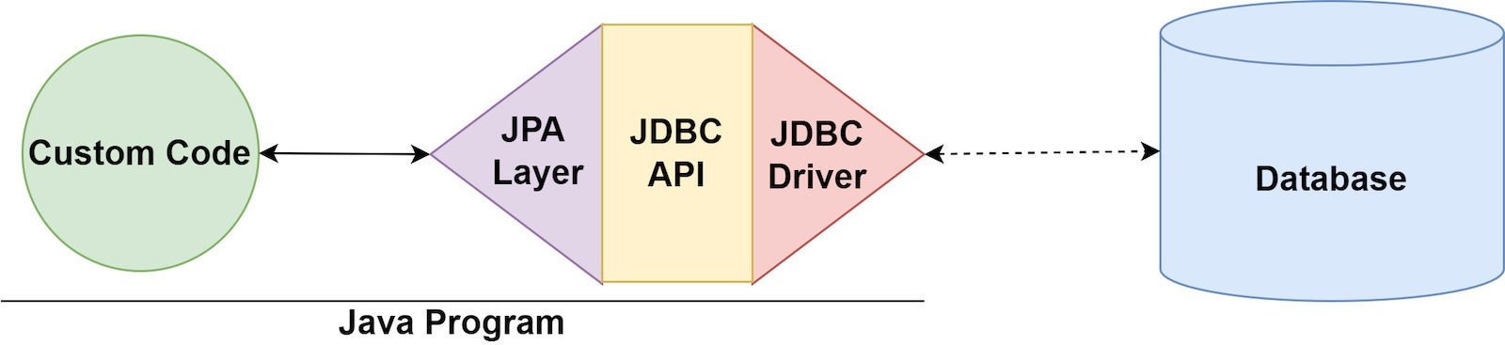

JAVA POJO Class
public class Employee {
private int id;
private String first_name;
private String last_name;
private int salary;

public Employee() {}
public Employee(String fname, String lname, int salary) {
this.first_name = fname;
this.last_name = lname;
this.salary = salary;
}

public int getId() {
return id;
}

public String getFirstName() {
return first_name;
}

public String getLastName() {
return last_name;
}

public int getSalary() {
return salary;
}
}

ORM Tool convert into Query

create table EMPLOYEE (
id INT NOT NULL auto_increment,
first_name VARCHAR(20) default NULL,
last_name VARCHAR(20) default NULL,
salary INT default NULL,
PRIMARY KEY (id)
);

Java ORM Frameworks
Enterprise JavaBeans Entity Beans
Java Data Objects
Castor
TopLink
Spring DAO
Hibernate
And many more
JPA Representation in java

Difference Between JDBC and Hibernate

JDBC Architecture

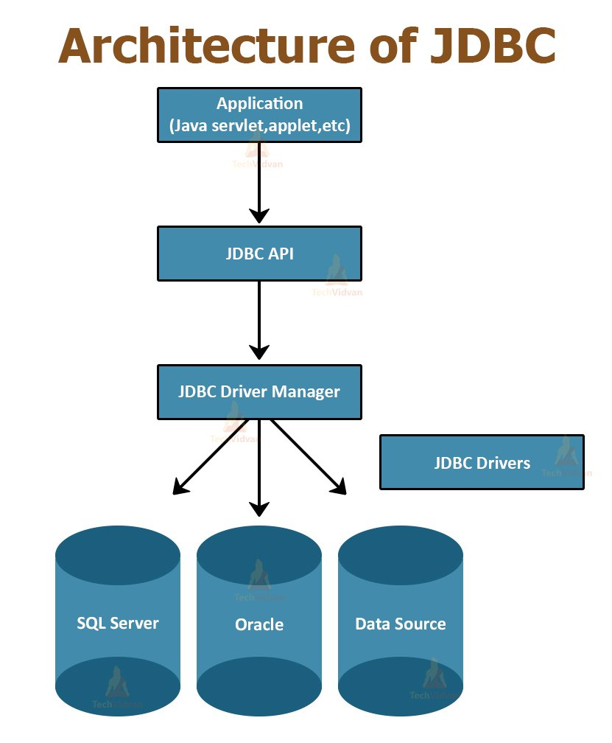

Hibernate

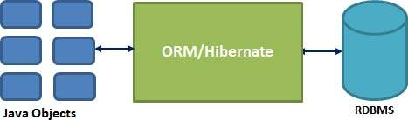

1. JDBC is an API that defines how a client can access a database; Hibernate is an ORM library that provides a framework for mapping an object-oriented domain model to a traditional relational database.

2. JDBC allows various implementations to exist and by used by the same application; Hibernate maps from Java classes to database tables.

S.No | JDBC | Hibernate
1. | In Jdbc, one needs to write code to map the object model data representation to the schema of the relational model | Hibernate maps the object model’s data to the schema of the database itself with help of annotations or xml
2. | JDBC enables developers to create queries and update data to a relational database using SQL | Hibernate uses HQL (Hibernate Query Language) which is similar to SQL but understands object oriented concepts like inheritance, association etc.,
3. | JDBC code needs to be written in a try catch block as it throws checked exceptions (SQLException) | Where as Hibernate manages the exceptions itself by making them as unchecked.
4. | JDBC is Database dependent i.e one needs to write different codes for different databases. | Where as Hibernate is database independent and same code can work for many databases with minor changes
5. | Creating Associations between relations is quite hard in JDBC | Associations like one-to-one, one-to-many, many-to-one and many-to-many can be acquired easily with the help of annotations.

Hibernate

- Hibernate is an ORM framework and a JPA implementation.
- It is an open-source persistent framework.
- Hibernate takes care of mapping Java classes to database tables using XML files and without writing any line of code.
- Hibernate does not require an application server to operate.
- Provides simple querying of data.

Hibernate Supported Databases
- HSQL Database Engine
- DB2/NT
- MySQL
- PostgreSQL
- Oracle
- Microsoft SQL Server Database
- Sybase SQL Server

Hibernate Architecture
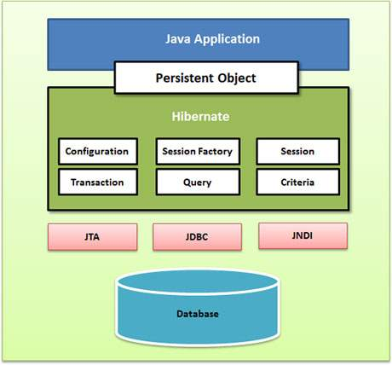

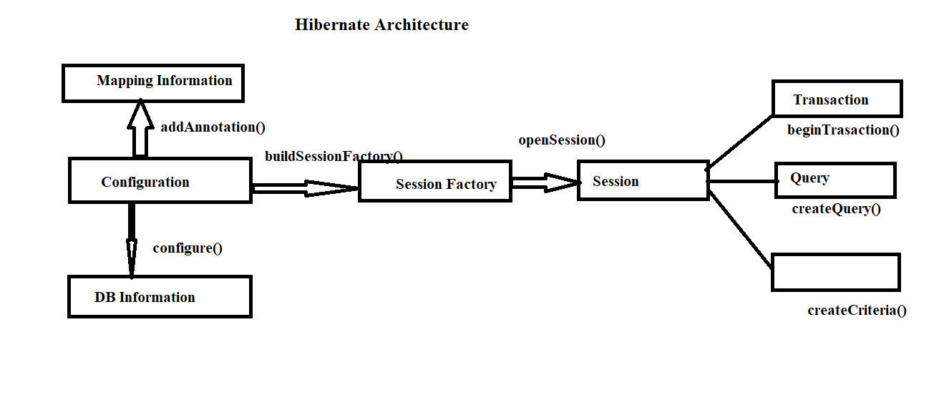

There are 6 types of object are using to perform crud operations
1.Configuration:
The Configuration object provides two keys components −
- Database Connection − This is handled through one or more configuration files supported by Hibernate. These files are hibernate.properties and hibernate.cfg.xml.

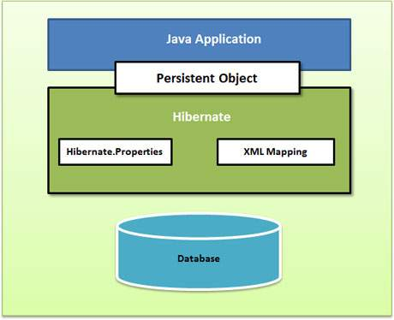

- Class Mapping Setup − This component creates the connection between the Java classes and database tables.
  - Xml based mapping
  - Annotation based mapping

- Configuration:- It is a class which is present in org.hibernate.cfg package It activates Hibernate framework. It reads both configuration file and mapping file.
Configuration cfg = new Configuration();
cfg.configure("hibernate.cfg.xml");
- It checks whether the config file is syntactically correct or not
- If config file is not valid then it will throw exception, if it is valid then it creates a Meta-data in memory and returns the meta-data object to reprasent config file.

2. SessionFactory Object
- SessionFactory allows for a Session object to be instantiated.
- One SessionFactory object per database using a separate configuration file.
- So, if you are using multiple databases, then you would have to create multiple SessionFactory objects.
- It is a interface which is present in org.hibernate package and it is used to create SessionFactory Object

SessionFactory sf = cfg.buildSessionFactory()
3. Session Interface Methods
- It is also a interface, it is present in org.hibernate package
- It opens the connection/session with database s/w through Hibernate framework
- It is a light weight object and it is not thread safe
- Session object is used to perform CRUD Operations
Session s = sf.openSession()
4. Transaction Object
A Transaction represents a unit of work with the database and most of the RDBMS supports transaction functionality. Transactions in Hibernate are handled by an underlying transaction manager and transaction (from JDBC or JTA).
=> Transaction object is used when ever we perform any operation and based upon that operation there is some change in database.
=> Transaction object is used to give the instruction to the database to make the changes that happen because of operation as a permanent by using commit() method.
Transaction tx = session.beginTransaction();
tx.commit();

5. Query Object
Query objects use SQL or Hibernate Query Language (HQL) string to retrieve data from the database and create objects. A Query instance is used to bind query parameters, limit the number of results returned by the query, and finally to execute the query.
- session.save(employee);
- session.update(employee);
- session.delete(employee);
6. Criteria Object
Criteria objects are used to create and execute object oriented criteria queries to retrieve objects.
Criteria criteria = s.createCriteria();

Perform CRUD Operations using Hibernate Project
There are 2 types of Hibernate mappings
- Xml based Mapping
- Annotation based Mapping

XML based Mapping

Hibernate Project using XML based mapping
Step1: Create Maven Project quickstart project
Step2: add Hibernate and MySql dependencies in pom.xml
<!-- https://mvnrepository.com/artifact/com.mysql/mysql-connector-j -->
<dependency>
<groupId>com.mysql</groupId>
<artifactId>mysql-connector-j</artifactId>
<version>9.5.0</version>
</dependency>

<!-- https://mvnrepository.com/artifact/org.hibernate/hibernate-core -->
<dependency>
<groupId>org.hibernate</groupId>
<artifactId>hibernate-core</artifactId>
<version>7.2.0.Final</version>
</dependency>

Step3: Create Model package and create Java POJO/Persistence Class
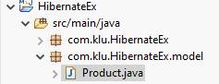
package com.klu.HibernateEx.model;

public class Product {

private int pid;
private String pname;
private int price;

public int getPid() {
return pid;
}
public void setPid(int pid) {
this.pid = pid;
}
public String getPname() {
return pname;
}
public void setPname(String pname) {
this.pname = pname;
}
public int getPrice() {
return price;
}
public void setPrice(int price) {
this.price = price;
}
}

Step4: Create resource source folder (src/main/resource) and create Hibernate Configuration file (hibernate.cfg.xml ) and Persistence Class Mapping file (Product.hbm.xml)
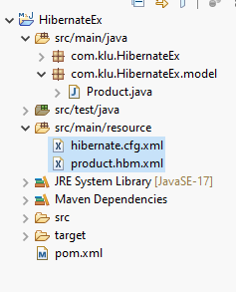
hibernate.cfg.xml

<hibernate-configuration>
<session-factory>
<!-- Database -->
<propertyname="hibernate.connection.driver_class">com.mysql.cj.jdbc.Driver </property>
<property name="hibernate.connection.url">jdbc:mysql://localhost:3306/hibernate_db</property>
<property name="hibernate.connection.username">root</property>
<property name="hibernate.connection.password">root</property>

<!-- Hibernate -->

<!--<property name="hibernate.dialect">org.hibernate.dialect.MySQL8Dialect</property>-->
<property name="hibernate.show_sql">true</property>
<property name="hibernate.hbm2ddl.auto">create</property>

<!-- Mapping -->

<mapping resource="product.hbm.xml"/>

</session-factory>
</hibernate-configuration>

Product.hbm.xml
<hibernate-mapping package="com.klu.HibernateEx.model">
<class name="Product" table="product">
<id name="pid" column="pid"/>
<property name="pname" column="pname"/>
<property name="price" column="price"/>
</class>
</hibernate-mapping>
Step 5 : Call SessionFactory, Session and Transaction in Main method to perform CRUD Operations.

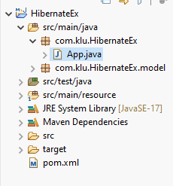

package com.klu.HibernateEx;
import org.hibernate.Session;
import org.hibernate.SessionFactory;
import org.hibernate.Transaction;
import org.hibernate.cfg.Configuration;
import com.klu.HibernateEx.model.Product;

public class App {
public static void main(String[] args) {

Configuration cfg = new Configuration();
cfg.configure("hibernate.cfg.xml");
SessionFactory sf = cfg.buildSessionFactory();
Session session = sf.openSession();
Transaction tx = session.beginTransaction();
Product p = new Product();
p.setPid(1);
p.setPname("mobile");
p.setPrice(2000);
session.persist(p);
tx.commit();
session.close();
sf.close();
System.out.println("table created and data inserted");
}
}

Hibernate CRUD Operations
- CREATE when pojo class object executed
- INSERT session.save(pojo class object)
- DETELET session.delete(pojo class object)
- UPDATE session.update(pojo class object)
- SELECT session.get(pojo class object)

Select
System.out.println("---- PRODUCT TABLE DATA ----");
for (int id = 1; id <= 10; id++) {
Product prod = session.get(Product.class, id);
if (prod != null) {
System.out.println(
prod.getPid() + " " +
prod.getPname() + " " +
prod.getPrice()
);
}
}
INSERT

Product p = new Product();
p.setPid(1);
p.setPname("mobile");
p.setPrice(2000);
session.persist(p);

DELETE
Product prod = session.get(Product.class, 1);
if (prod != null) {
session.delete(prod);
System.out.println("Product deleted successfully");
} else {
System.out.println("Product not found");
}

UPDATE

Product prod = session.get(Product.class, 1);
if (prod != null) {
prod.setPname("Smart Mobile");
prod.setPrice(18000);
System.out.println("Product updated successfully");
} else {
System.out.println("Product not found");
}

HQL (Hibernate Query Language)

- Hibernate Query Language (HQL) is an object-oriented query language used in Hibernate to interact with the database.
- HQL works with persistent objects (entities) and their properties.
- HQL is database-independent, meaning queries are written in terms of entity classes and attributes
- Hibernate automatically translates them into the appropriate SQL for the underlying database.

Hibernate Query Language (HQL) Clauses

- FROM Clause
- SELECT Clause
- WHERE Clause
- ORDER BY Clause
- UPDATE Clause
- DELETE Clause
- INSERT Clause

Database Table Java Entity

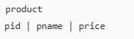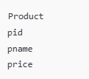

From clause (Display FULL Table)

To load a whole persistent object into memory, the FROM clause is used.

SQL: SELECT * FROM product;

HQL:

Query<Product> query = session.createQuery("from Product", Product.class);
List<Product> list = query.list();
for (Product p : list) {
System.out.println(
p.getPid() + " " +
p.getPname() + " " +
p.getPrice()
);
}

SELECT Clause ( SELECT Specific Columns)

The SELECT clause is used when only a few attributes of an object are required rather than the entire object.

SQL: SELECT pid,pname FROM product;

HQL:
Query<Object[]> query = session.createQuery("select pid, pname from Product");
List<Object[]> list = query.list();
for (Object[] row : list) {
System.out.println(row[0] + " " + row[1]);
}

WHERE Clause (HQL with WHERE Condition)

Filtering records is done with the WHERE clause. It's used to retrieve only the records that meet a set of criteria.

SQL: SELECT * FROM product WHERE price > 20000;

HQL:
Query<Product> query = session.createQuery("from Product where price > 20000", Product.class);
List<Product> list = query.list();

ORDER BY Clause
The ORDER BY clause is used to sort the results of an HQL query.

SQL: SELECT * FROM student WHERE id > 5 ORDER BY id DESC;

HQL
String hib = "FROM Student S WHERE S.id > 5 ORDER BY S.id DESC";
Query query = session.createQuery(hib);
List results = query.list();

UPDATE Clause
The UPDATE clause is required to update the value of an attribute

SQL : UPDATE product SET price = 18000 WHERE pid = 1;

HQL:
Query query = session.createQuery("update Product set price = 18000 where pid = 1");
int rows = query.executeUpdate();
tx.commit();
System.out.println(rows + " row updated");

DELETE Clause
It is required to delete a value of an attribute.

SQL: DELETE FROM product WHERE pid = 2;

HQL:
Query query = session.createQuery("delete from Product where pid = 2");
int rows = query.executeUpdate();
tx.commit();
System.out.println(rows + " row deleted");

INSERT Clause
It is required to Insert values into the relation.

SQL: INSERT INTO student (first_name, last_name) VALUES ('John', 'Doe');

HQL
String hib = "INSERT INTO Student(first_name, last_name) VALUES ('John','Doe')";
Query query = session.createQuery(hib);
int result = query.executeUpdate();

Create Hibernate Project to perform CURD Operations using HQL

App.java

package com.klu.hibernate;

import java.util.List;

import org.hibernate.Session;
import org.hibernate.SessionFactory;
import org.hibernate.Transaction;
import org.hibernate.cfg.Configuration;
import org.hibernate.query.Query;

import com.klu.hibernate.model.Product;

public class App {

public static void main(String[] args) {

// Create SessionFactory
Configuration cfg = new Configuration();
cfg.configure("hibernate.cfg.xml");
SessionFactory sf = cfg.buildSessionFactory();
Session session = sf.openSession();

// ---------------- CREATE ----------------
Transaction tx = session.beginTransaction();

Product p = new Product();
p.setPid(1);
p.setPname("Mobile");
p.setPrice(15000);

session.save(p);
tx.commit();
System.out.println("Record Inserted");

// ---------------- READ (HQL) ----------------
Query<Product> readQuery =
session.createQuery("from Product", Product.class);

List<Product> list = readQuery.list();
System.out.println("---- Product Table ----");
for (Product pr : list) {
System.out.println(
pr.getPid() + " " +
pr.getPname() + " " +
pr.getPrice()
);
}

// ---------------- UPDATE (HQL) ----------------
tx = session.beginTransaction();
Query updateQuery =
session.createQuery(
"update Product set price = 18000 where pid = 1");
int u = updateQuery.executeUpdate();
tx.commit();
System.out.println(u + " row updated");

// ---------------- DELETE (HQL) ----------------
tx = session.beginTransaction();
Query deleteQuery =
session.createQuery(
"delete from Product where pid = 1");
int d = deleteQuery.executeUpdate();
tx.commit();
System.out.println(d + " row deleted");

session.close();
sf.close();
}
}

